Report for FMS
Visit by Cath Adams and Nich Woolf to the Public Hospital, Mazar-i- Sharif, Afghanistan
Introduction
The first visit to Mazar-i-Sharif in 2011 delivered 150 Kgs of equipment and supplies and provided resuscitation training to medical staff in the public hospital. The objective was to improve the safety of surgery in response to a report by Dr Ray Allen pointing out the risks faced by visiting consultants from SGAA.
FMS – Festival Medical Services, charity providing healthcare at events and raising money for other charities worldwide.
GIZ - Gesellschaft fuer Internationale Zusammenarbeit, a German government funding body.
SCA – Swedish Committee for Afghanistan, a large NGO running health, education, disability and rural development programmes in Afghanistan.
SGAA – Sandy Gall’s Afghanistan Appeal, working in orthopaedic workshops and physiotherapy services, a partner of SCA’s disability programme, Rehabilitation for Afghans with Disabilities (RAD).
In 2011, GIZ were just completing the building of a new hospital which opened two weeks after the FMS visit. The Japanese tsunami in 2010 had, however, delayed the Japanese contract to supply new equipment to the hospital resulting in the new hospital being poorly equipped.
Although the objectives of the first visit had been achieved it was clear that there were fundamental problems of organisation that needed to be addressed. Contact, by email, was established with several Afghan staff and support was given at the same time information was gathered for another trip. Principle amongst these contacts was Dr Hamidullah Seddiqi. At the time he was completing the last of his visits to Norway training as an anaesthetist.
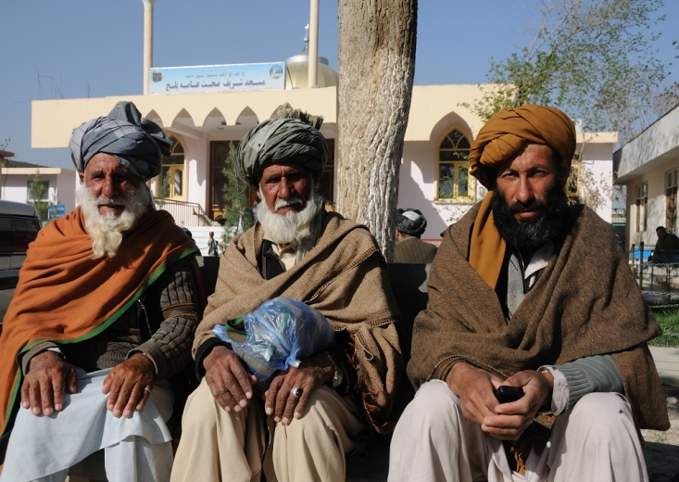
Afghan society is in transition from a feudal system to a more liberal system. The violent history, ancient and modern has shaped their thinking and led to considerable problems adapting to western conventions. Corruption in public life is rife and shapes many decisions made in the hospital.
There are plenty of dedicated Afghans in the hospital who are honest, loyal, altruistic and incredibly brave. Some have witnessed atrocities others have been threatened and some have had to leave their homes. They deserve support as their failure would have dire consequences to the healthcare of ordinary Afghans.
The 2013 visit was planned along the principle of capacity building; this time teaching them to teach rather than doing it for them. The objective was still to improve the safety of surgery but this time to train trainers and make the process self-sustaining.
The Visit
It quickly became apparent that Afghan medical staff has not been given any standards for resuscitation; most of what they know seems to come from Youtube. Enquiries revealed that there are no written guidelines in Dari or Pashto, the main languages of Afghanistan. A decision was made, whilst in the UK, to use the UK Resuscitation Council 2010 Guidelines; these are more clearly laid out. We were fortunate to able to get Dari translations of all the algorithms and include them in individual packs for each trainee instructor.
A lot of planning took place with FMS providing money to support the DDH (Developmental Dysplasia of the Hip) project run by RAD as well as the purchase of resuscitation manikins and an intubation trainer for the hospital in Mazar-i-Sharif. These were air freighted out to Kabul and despite delays in customs arrived in time for the training. As previously, equipment and supplies were donated from a variety of sources and transported by us as part of our luggage.
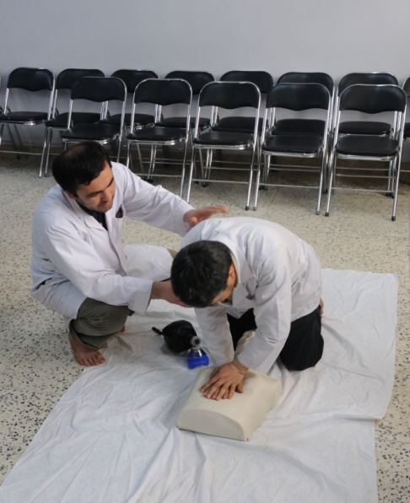
Arriving at the hospital in Mazar-i-Sharif contact was established with the key players to help plan how the training was to be delivered. Permission from the Director had been established to carry out the resuscitation training and the students had been selected. Training venues had been booked and training started within 24 hours of arrival. The students rose to the challenge and put in a lot of hard work to achieve a good standard. Dr Hamidullah, as an anaesthetist led on airway management and proved a good teacher. As noted in the previous report many of the required skills exist but are not coordinated into a proper organisation. Afghans seem prone to wanting all the advanced trappings of modern western medicine without the foundations that support them. To counteract this we provided two foundation blocks that could be linked to other issues. These were Basic Life Support ((BLS) and World Health Organisation Safe Surgery Checklist (WHO SSC).
BLS (Basic Life Support) could obviously benefit hospital staff. Beyond that the equipment available limited much more being done successfully. ALS (Advanced Life Support) requires having an ITU (Intensive Therapy Unit) and in Mazar the equipment has not yet arrived and the staff cover is not sufficient. There had been successful resuscitations in the recent past where relatives had been called upon to ventilate patients for several days, in the absence of necessary staff. After our training there were reports of successful resuscitations particularly in the neonatal and paediatric wards. This was extremely gratifying and provided the trainers with a real illustration of the value of BLS to them, the patients and the rest of the hospital staff.
Both building blocks were used to build team working and improve management of departments. With no trained theatre nurses and for instance no standard method of swab counting, introducing the WHO SSC was always going to be a challenge but we discovered support amongst the staff who could see the benefits. There are simple changes that could be made to enable the Safe Surgery Checklist to be implemented but this does require a change in attitude to some fundamental processes, for example, identifying patients that is not formalised at present. This was recognised by a lot of the senior staff as an issue that needs urgent attention.
The SCA RAD orthopaedic centre and physiotherapy clinic continues to provide a good example to the hospital of how a well managed and organised unit can be effective. In addition to the DDH and club foot clinics that FMS have helped to fund we also saw the home based physiotherapy service in action. Community based rehabilitation workers seek out patients and then accompany a physiotherapist to the patient at home to deliver treatment. This work makes a real difference to families who would struggle to cope with disabled children if it were not for this assistance.
When the hospital gets the outstanding equipment from the delayed Japanese contract they will be in a position to launch their Intensive care unit. They will need to remedy a number of staffing issues and to source physiotherapy for these patients. The training for the RAD physiotherapists could be easily achieved and lead to a closer working relationship between RAD and the hospital.
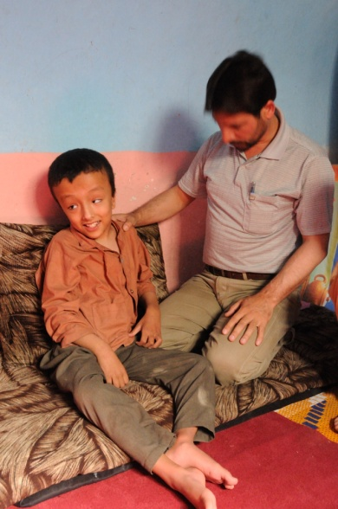
In the absence of any pre-hospital care the Police, Army and taxi drivers bring many patients into hospital with others carried in by family members. Inevitably this leads to complications of fractures and compromise of airways. We wanted to run a very simple casualty handling course for the Police and Army and attempted to find contacts. This proved impossible at first and whilst the security situation seemed less tense than the last time individuals in uniform seemed reluctant to interact with westerners.
Mass Casualty Triage (MCT) was an issue that was partly addressed on the last visit and a training course was devised to be explained to selected individuals so that they could implement training to the MIMMS standard in Mazar I Sharif.
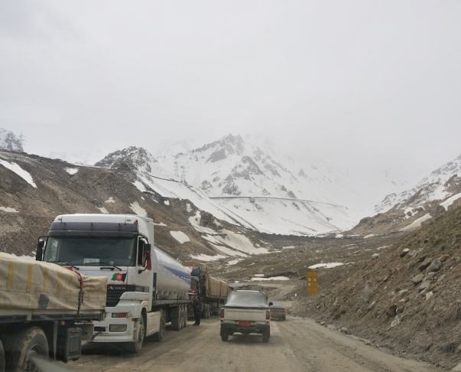
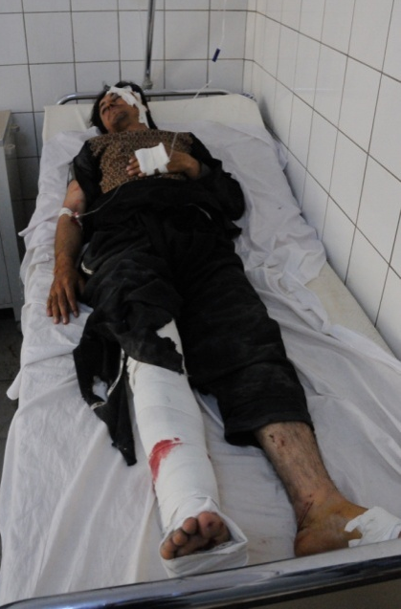
During the visit an approach was made by Aid Medicale Internationale (AMI) to provide training in Kunar Province in preparation for an expected upsurge in terrorist activity. There was no time to visit this remote region and the security situation there is extremely poor. We arranged, instead, to run a course in Kabul on our last day in the country for 10 senior staff. This course was specifically designed for small hospitals and health facilities with no pre-hospital care. The sieve and sort model was explained along with issues of safety and doing the most for the most. Unfortunately at the last minute floods in the North prevented us travelling by air and we had to go by road through the Salang tunnel. The course had to be cancelled although we had the experience of the route taken by many seriously ill patients being transferred to Kabul. This is a horrendous and perilous journey for the fit and well let alone ill and traumatised patients and highlighted the need for further assistance in training and expertise to prevent this having to happen so frequently. The doctors in Mazar-i-Sharif, although skilled in many general areas do not have the opportunity to have training in specialities for example maxillofacial trauma and neurosurgery. This means that facial trauma and head trauma have to undergo the journey to Kabul by road taking on average 12hrs to complete, through regions at high altitude and through a tunnel which is full of exhaust fumes and which is subject to being affected by frequent avalanches.
Emergency, the hospital’s name for A&E was the centre of much debate. Although they processed patients quickly to specialities they seemed to skip the basic observations and at times sent patients to inappropriate places for treatment. By chance we took the opportunity to demonstrate the standard of care that we expected from the staff. A 14 year old boy, struck by a car was brought in with a serious head injury and a compromised airway. Although the patient’s condition gave every appearance of severe brain damage observations were carried out in a standard manner, his airway secured, his O2 saturations improved and he was later transferred to a neurosurgery unit in Kabul. We are unaware how he fared on the journey but the likelihood is that he did not do well.
There are many patients who suffer facial trauma both soft and hard tissues and generally speaking these injuries are severe but potentially easily approached with the right equipment and training. We delivered 2 osteosynthesis plating sets donated from Prince Charles Hospital, Merthyr Tydfil. Although we discovered that there were no drills to enable its use and the skills to deal with this type of trauma are very limited both in terms of surgical expertise and post-operative care facilities. We discovered interest in maxillofacial trauma surgery training from a senior orthopaedic surgeon at the hospital, an ENT surgeon from the Afghan Army and a dentist who has some limited maxillofacial surgery experience in Germany. This is being considered as to the best way forward to help them with this as at present all these patients have to be transferred to Kabul for treatment. With the arrival of the equipment from Japan and some training this will hopefully improve the surgical skills and post-operative facilities for facial surgery patients. We were also asked to see several other types of oral and facial surgery patients and several of these had advanced malignancies which have to go to Pakistan to be treated although potentially these may be treated in Mazar once the surgical skills and post-operative care is improved as there is vascular surgery expertise available and with an integrated team approach this is feasible in the future.
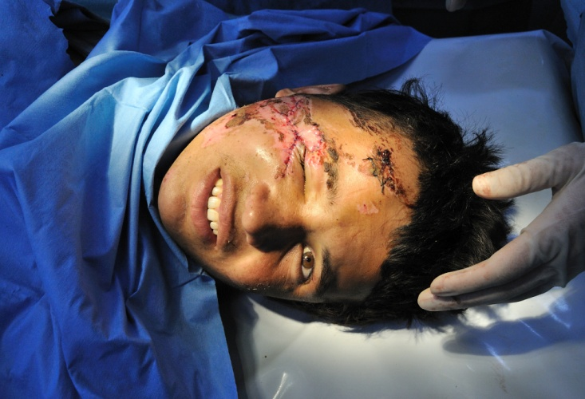
A success story from the maxillofacial surgery side was a young man who had fallen in the hills and sustained a fractured femur and an extensive de-gloving facial laceration with some tissue loss involving his right cheek, temple and outer part of his right eye. This was debrided and sutured in theatre and elicited considerable interest from the other surgeons in the hospital. It was strange to have such a big audience coming and going but I am glad to say that the laceration has healed well. As it happened this proved to be a good teaching opportunity in safe surgery and was an excellent example of teamwork as so many people were involved in the planning, execution and observation of this successful operation.
Contact was made with the nearby medical school which was keen to introduce resuscitation training to an up to date international standard. We were delighted to form a link so that the resuscitation trainers from the hospital and the FMS supplied manikins could be used for this wider audience.
Conclusions
- We believe that there is the potential for a safe environment for patients and staff
- The hospital staff need ongoing support to maintain and build on these initiatives
- We have met staff who are brave, dedicated and altruistic
- These people must be supported and retained
- Voluntary organisations and charitable gifts are available from many sources and should be sought out
- Linking with overseas and Afghan hospitals may be a good source of both equipment, training and expertise
- A hospital is nothing without its staff
- Simple solutions make more lasting impact than complicated ones

- There is scope for RAD to provide physio services for the hospital departments, such as ITU.

- The DDH project in Samangan is well run and the FMS funding is well placed.
Thanks to our colleagues at SGAA and at SCA in helping to facilitate the trip as well as the team in SCA RAD in Mazar-i-Sharif.

